## Capgemini India

**MIS System**

Date: 17*-Nov-2017*

|  |  |  |  |  |  |
| --- | --- | --- | --- | --- | --- |
| **Version** | **Implemented**  **By** | **Date** | **Approved**  **By** | **Approval**  **Date** | **Remark** |
| 1.0 | Sunil Patel | 12/12/2017 |  |  |  |

Objective 4

Scope 4

Summary 4

Design Overview 5

**Business overview**…………………………………………………........6

**Operational fundamental of MIS……………………………………………………….10**

**Required Infrastructure …………………………………………….12**

**Objective**

This document provides a comprehensive architectural overview of MIS system for RPA practice.

The document depicts the technical aspects of MIS System Components and is intended to capture and convey the significant architectural design decisions which have been made in preparation for the development of the MIS Web Application.

# Scope

MIS will be designed to connect all RPA resourceof capgemini to central system. Also MIS will help mangers to run their department effectively.

MIS is the primary focus of this document. As the enterprise resource management for capgemini, MIS captures and distributes a wide variety of resource data. System data and functionality support RPA practices, central services (such as resource management, project management, and certification management), and strategic planning across capgemini.

MIS currently includes the following components

1. RPA Resource
2. Trainer
3. Admin

**System Design Overview**

MIS Web API

MIS Web Application

OTH System DB

Console Application (scheduler)

Other system API

MIS DATA BASE

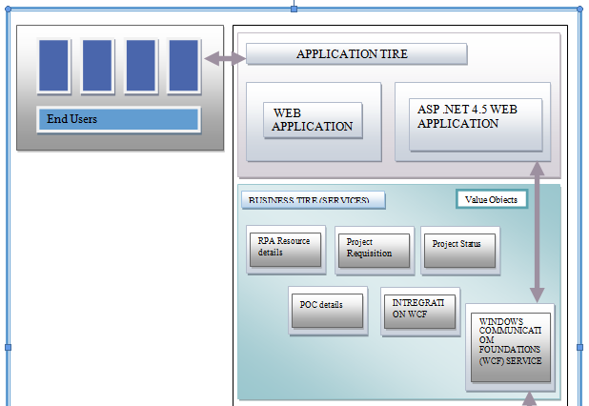 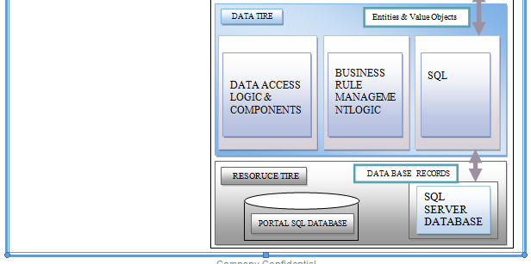

**Business overview**

MIS is divided into the functional components listed below. The components are tightly integrated. Data entered into any component flows throughout the system to those processes that use the data

* **Admin:** “the people and their information.” Creates and maintains information about RPA resource. Also processes certification and project management
* **Trainer:** “the people and their information.” Approve consolidation exercise, certification and maintains information about RPA certified resource also scheduled new training.
* **RPA Resource:** Update personal information, Skills, add certification and consolidation exercise also upload Resume in CG format.
* **Other System Integration:** MIS will intricate with others system to pull data related to project and new RPA resource.

**Operational fundamental of MIS**

**Admin -** MIS admin have following features

**RPA Resource Registration:** Admin can registor new resource information in mis system.

**Bluk upload** : admin have a feature to upload multipal resource information.

**Project Management**: Admin have following feature

* + - * Project planning
      * Team collaboration
      * Time tracking
      * Reporting

**Resource management:** download resource list, approve certification etc.

**Change Password**

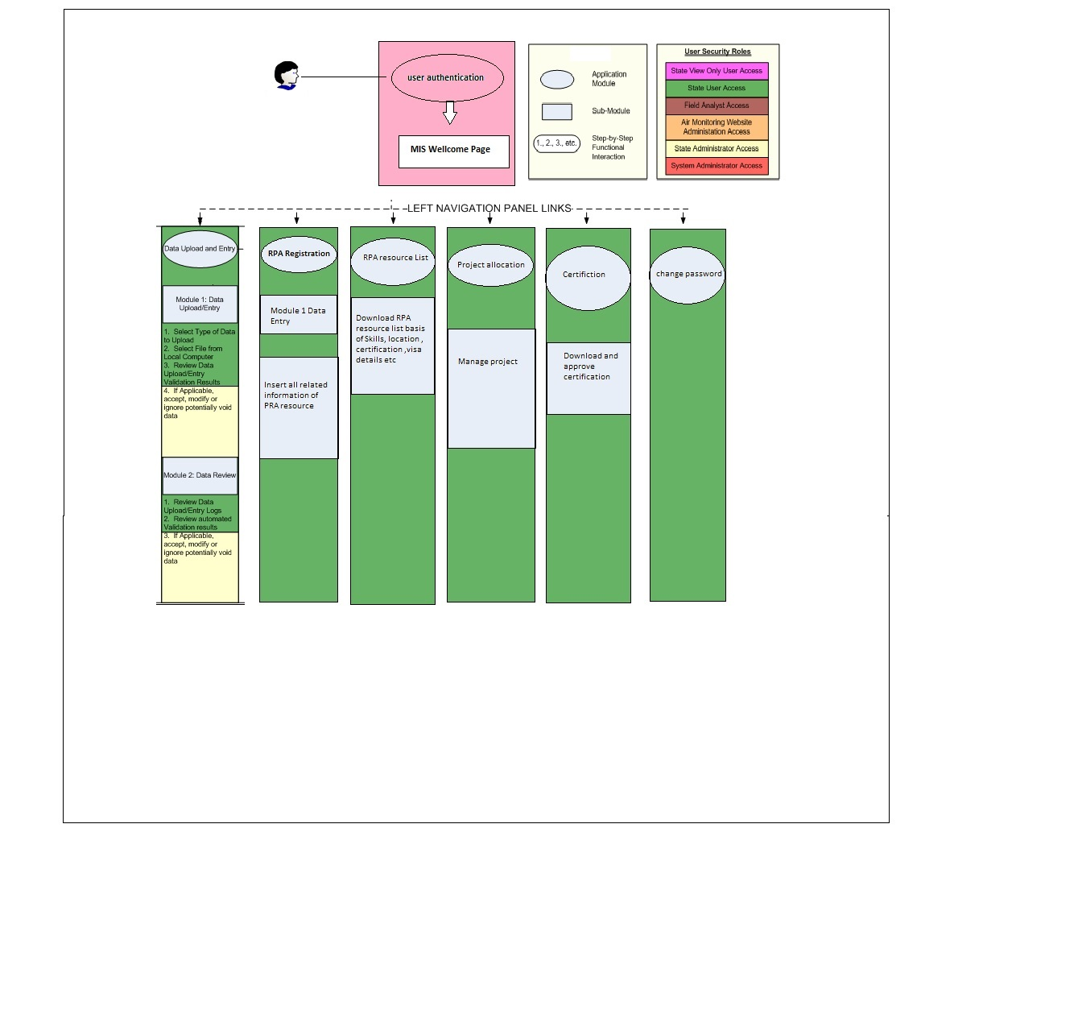

**Trainer:** MIS trainers have following features

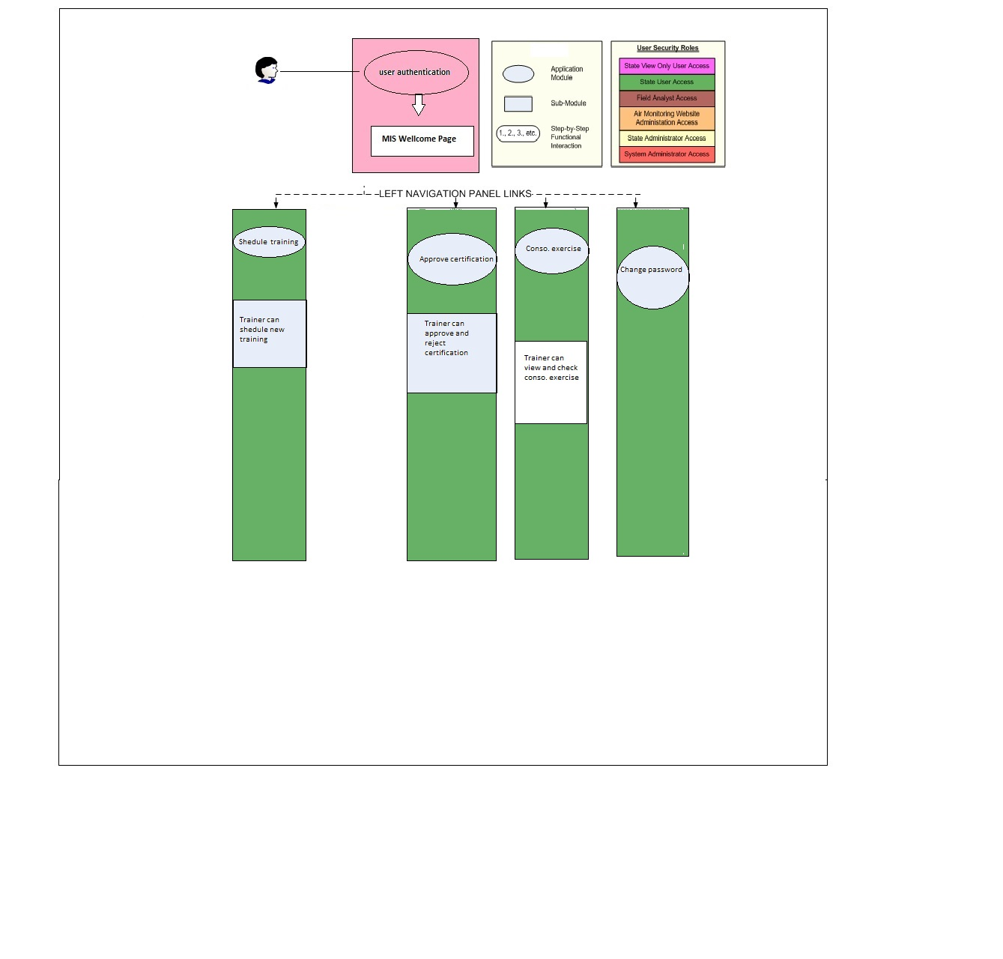

**RPA Resource**:MIS Resource have following features

* Insert and Update Personal Information
* Insert and update Skills
* Insert and update Visa details
* Insert and update Passport details
* Upload certification for approval
* Upload consolidation exercise for approval
* Upload Resume in CG format

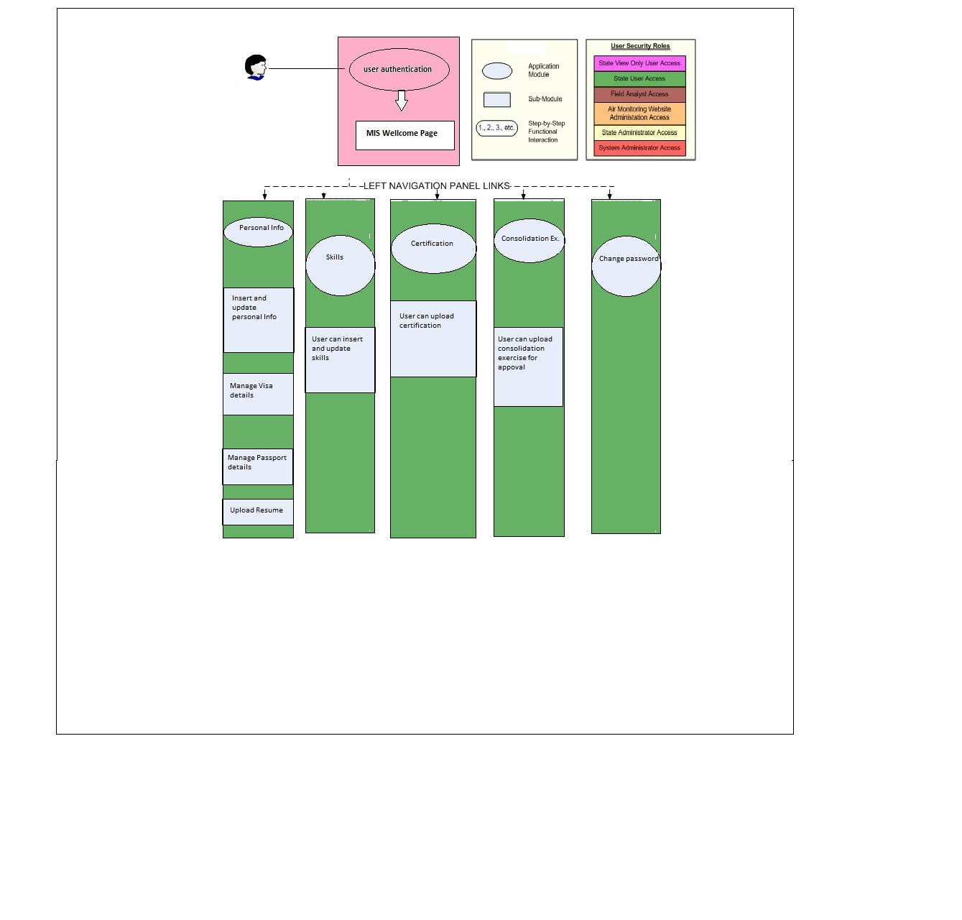

**Prototype**

**Admin Panel**

Login

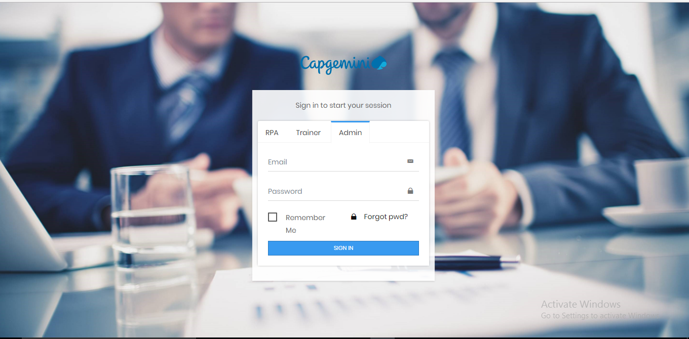

# Dashboard

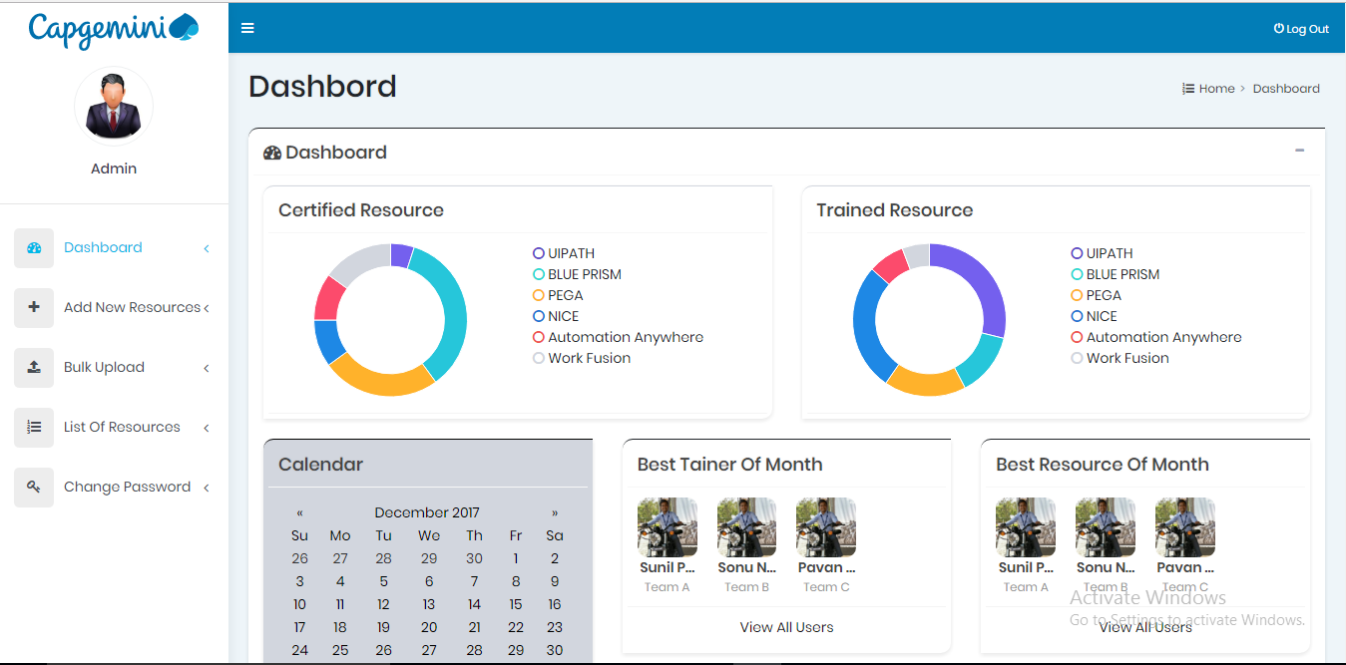

Add New Resource

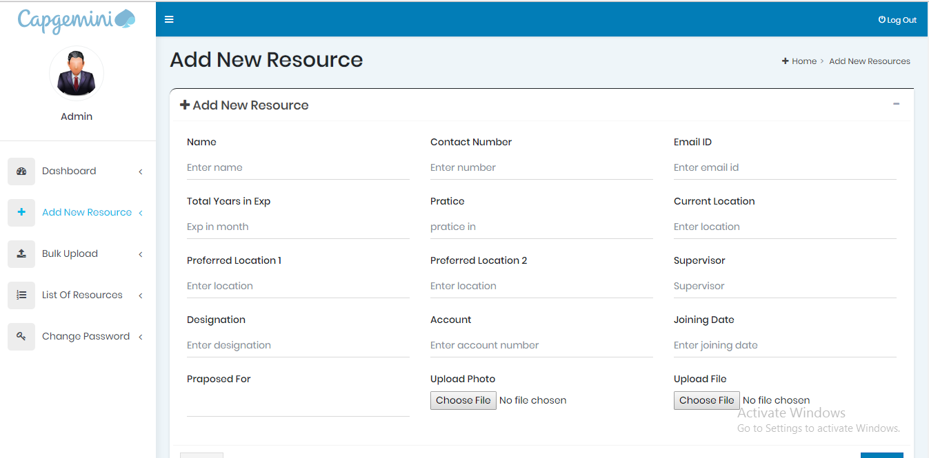

Bulk Upload

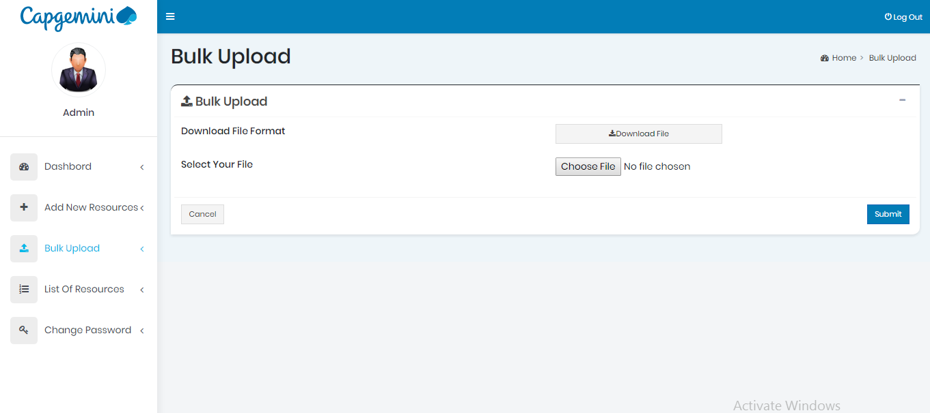

List Of Resource

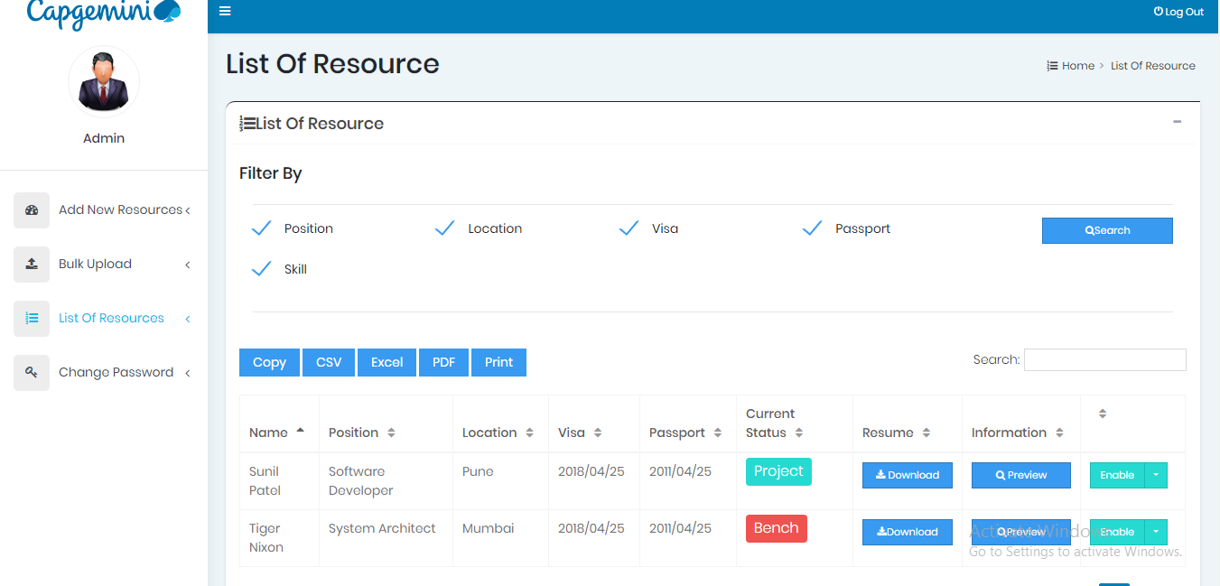

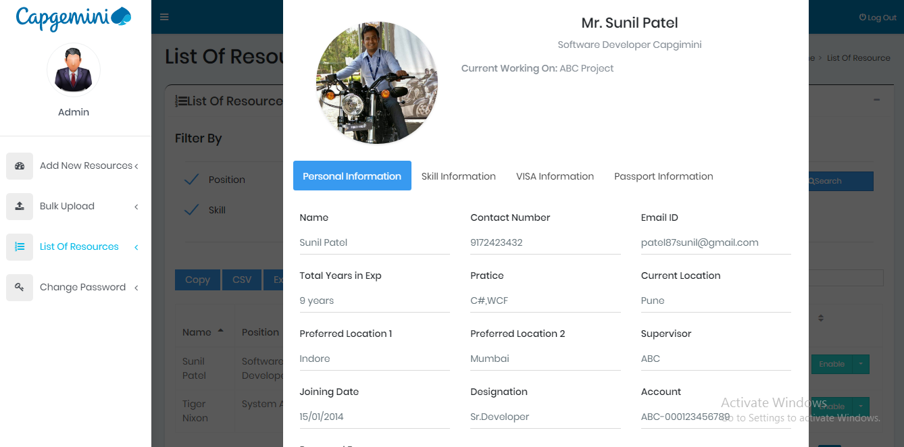

Change Password

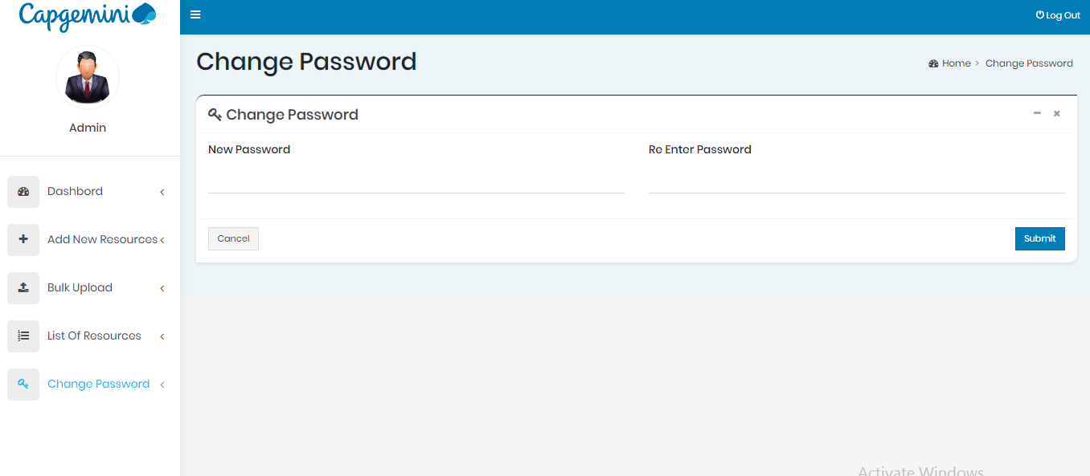

**Trainer**

Login

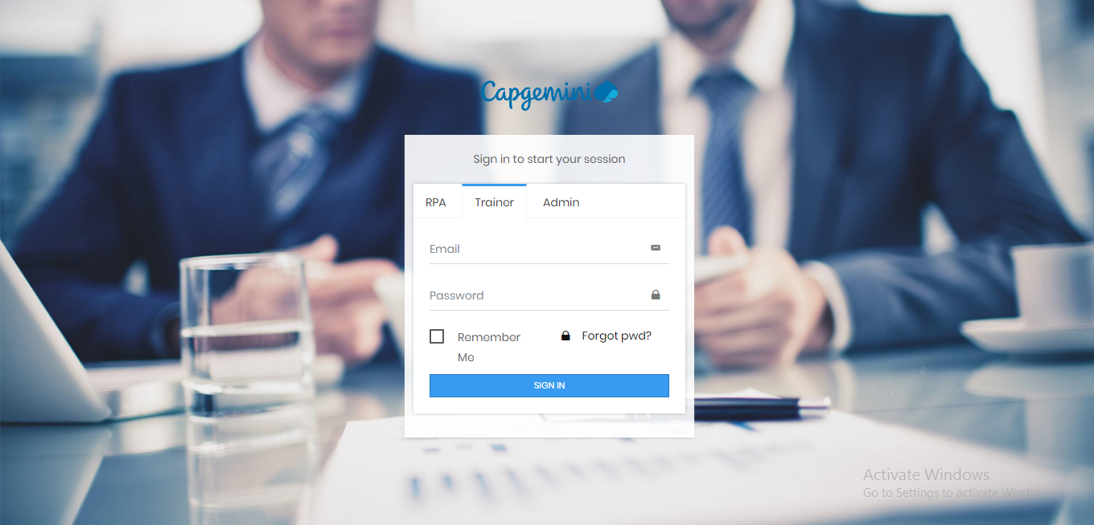

**Certification Details**

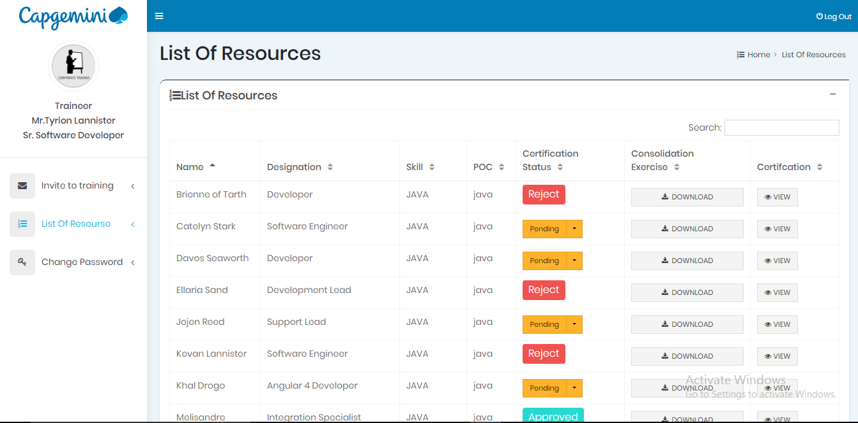

**Scheduled New Training**

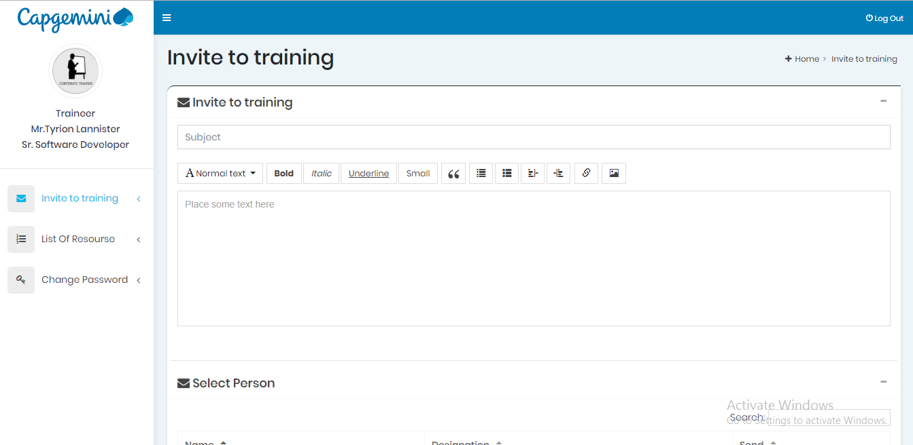

**Change Password**

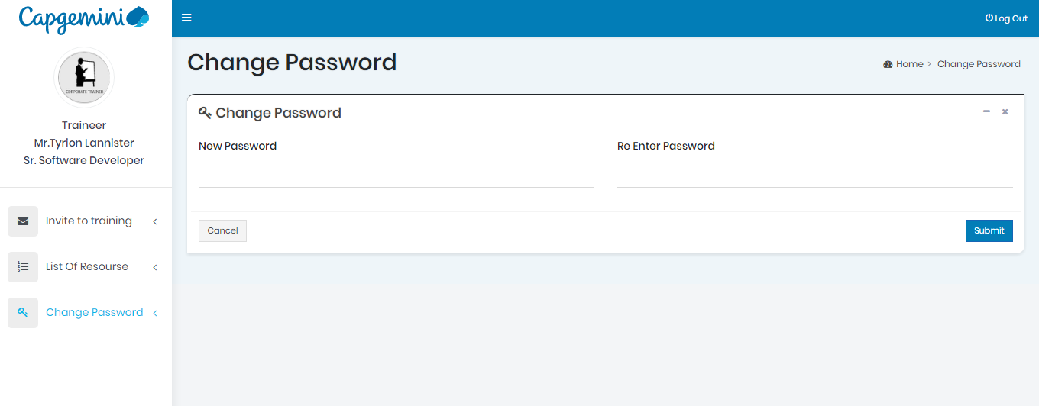

**RPA Resource**

**Login**



**Personal Information**

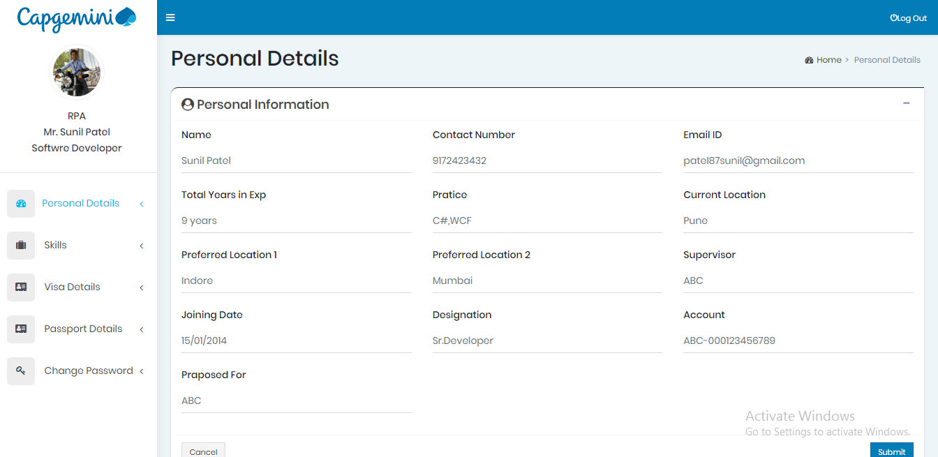

**Skills**

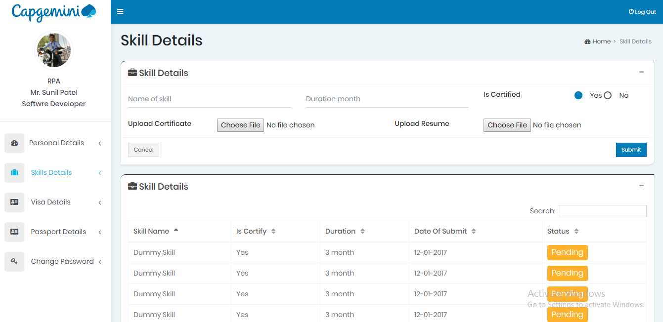

**Visa details**

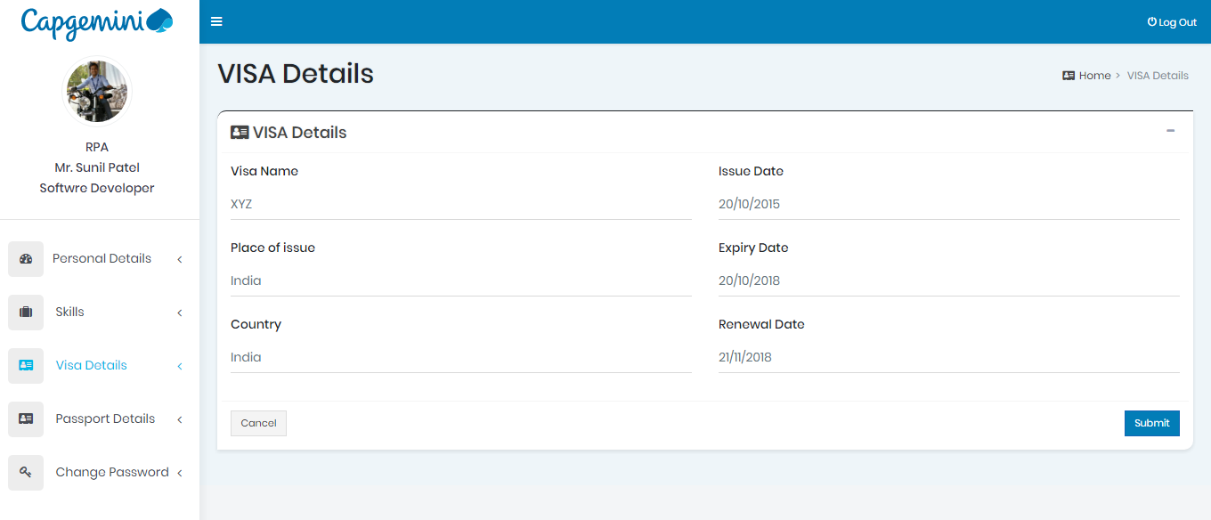

**Passport Details**

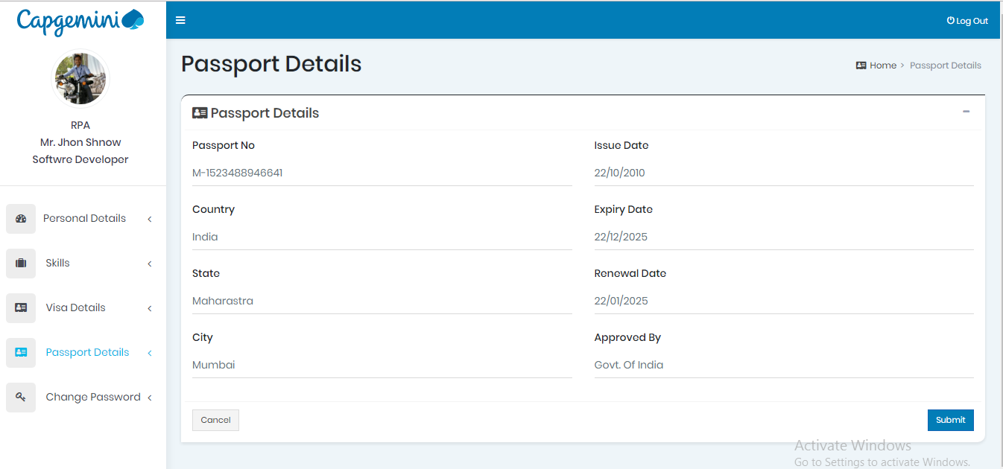

**Change Password**

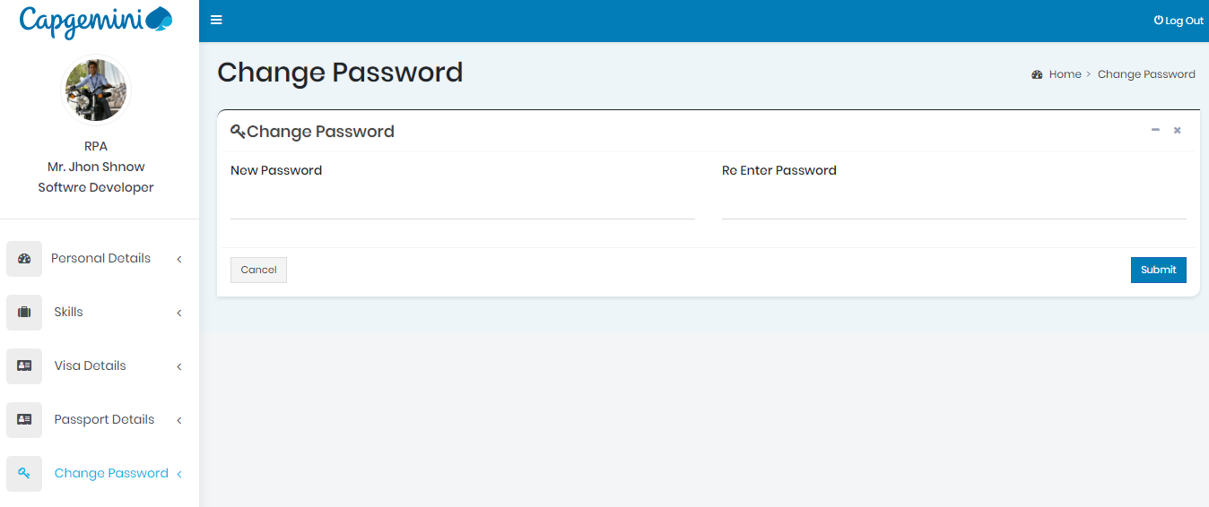

**Required Infrastructure**

* **Visual Studio 2012,**
* **SQL Server 2012**
* **IIS 6/7**
* **Window server**
* **Chrome**
* **Mozila**
* **Postmen**

***Minimum Server Hardware Requirements:***

* 2GHz+ (dual core) processor
* 16+ GB RAM
* 60GB free hard drive space (or an appropriate amount for additional file storage)
* Dedicated server or Dedicated Virtual Server Environment

***Server Software Requirements:***

* Windows Server 2012+ 64-bit Server
* [Microsoft SQL Server 2012+ 64-bit Standard Edition](http://www.projectinsight.net/project-management-software/features/sql-server) Processor License, service packs up to date
* IIS 6/7+ configured for ASP.Net 4.0
* IIS SMTP Service (or other SMTP server which allows relay from the web server)